Year 4 Spring 1 – Electricity Homework
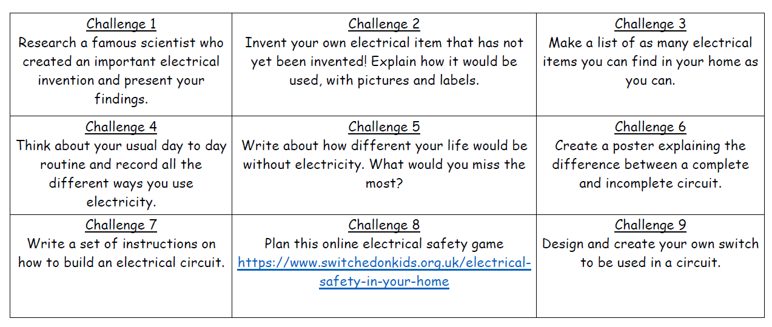
In school this half term we are learning about electricity, here are 9 learning challenges based on electricity. Please aim to complete the challenges over this half term (1 challenge each week). Try to think of different ways to present your work and be as creative as possible! (Some of the challenges may be more beneficial to do later on in the half term once the children have more knowledge about electrical circuits.)

Year 4 Spring 1 – Geography (Water) Homework
In school this half term we are learning about Water, here are some tasks. Please aim to complete over this half term (1 task each week). Try to think of different ways to present your work and be as creative as possible!


