Year 5 Homework: Summer 2
Choose any piece of homework to complete each week. Be as creative, imaginative and most importantly resourceful!
Also include spellings, TTRS and daily reading aloud.
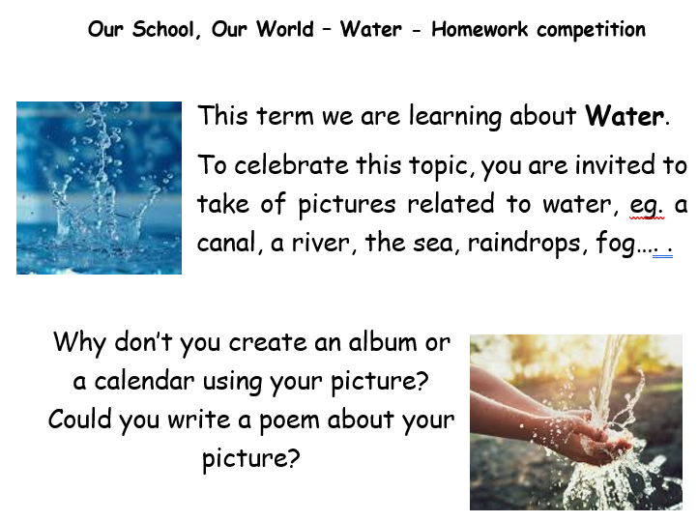

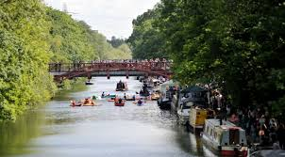  Create your own fact file about the River Soar.  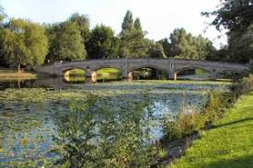 | Produce a postcard about a place that is special to you. It could be a place that you have been on holiday to, somewhere you used to live or somewhere you would like to go on your own.  - Describe where the place is  - Describe what the place is like  - Include a picture (photo or drawing)  - Explain why this place is special to you
What is human lifecycle? Draw or write the main stages of human development in order.  Extension: Compare human to animal lifecycle for 2 house points.  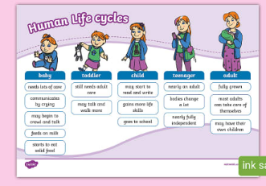  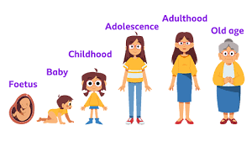 | 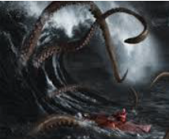  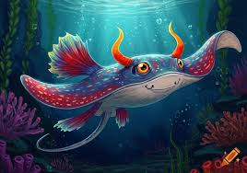  Write a short story with a river theme.  Is there a river monster of creature that comes to life! Have fun and be imaginative!
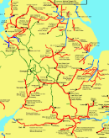
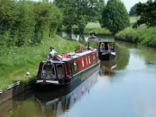
Research why were canals created in the UK and how were they used?
Create your own map of our local canals.

