Year 5 Homework: Summer
Choose any piece of homework to complete each week. Be as creative, imaginative and most importantly resourceful!
Also include spellings, TTRS and daily reading aloud.
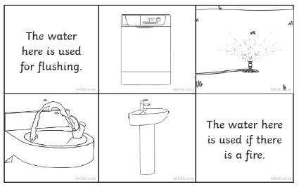  How do we use water? create diagrams to illustrate your findings. | Create a poster about saving water.  
  Explain who you think has a stronger argument for the reasons for Climate change?  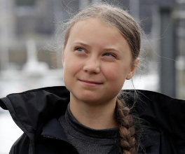  Greta Thunberg or Donald Trump | Draw a map of the world. Plot on your map the animals which are most endangered to those parts.  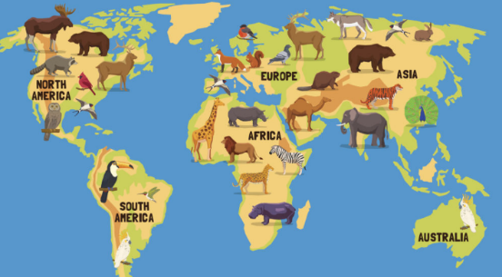
Refresh your prior knowledge and label parts of a flower. You can draw a diagram or disect and label parts of a real flower!  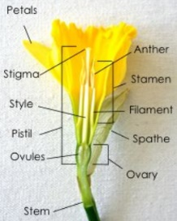  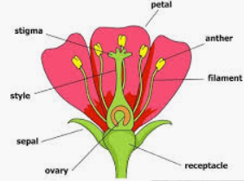 | Select an animal fo your choice and describe its lifecyle, its habitat and its behaviours.  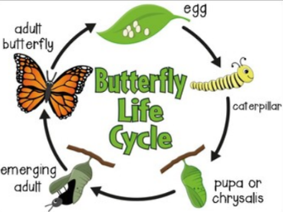  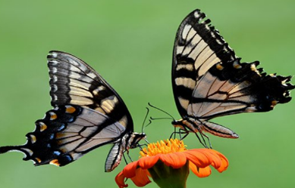  (You could even choose humans!)
This is a portrait. Have a go at making your own or of someone you know!  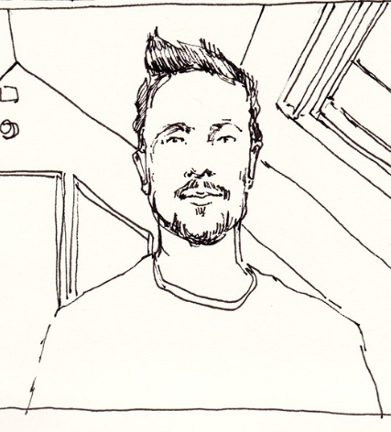 | Create or re-create a landscape masterpiece. Use whatever materials you like!  

