Autumn 1 - Homework grid - Earth and Space
Choose one activity a week from the grid below. Bring your tasks to school by Wednesday each week

1. Complete a character study of Neil Armstrong or any other famous astronaut/ cosmonaut. | 2. Create a new mnemonic that will help others in the  class remember the names of the planets and their order from the sun. | 3. Use scrap paper, foil, sweet wrappers and other junk  around the house to create your own space collage.
4. Write newspaper report about the first moon landing. 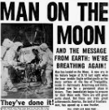 | 5. Keep a sky at night journal for a whole week. Write  about everything you can see in the sky. You could draw a picture of the moon every  night. Does it change over the course of the week? | 6. Find out facts about the space missions –  What was the first creature sent into space?  Who was the first astronaut?  Who was the first man on the moon?  What other interesting facts can you find?
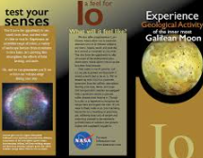  11. Create a travel brochure for the Moon. | 8.Make an acrostic poem for one of the planets  e.g. M  A  R  S | 9. Find out how far the Earth is from the Sun and then multiply it by 10. What method will you use?
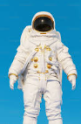  10. Design a new uniform for an astronaut landing on Mars, what features will it need to have? | Remember to practise your spellings and multiplication! | 7. Write a recipe for a dish using leftover food. Minimise food waste and maximise flavour with our expert tips and ideas today!

