https://www.oxfordowl.co.uk/login?active-tab=students

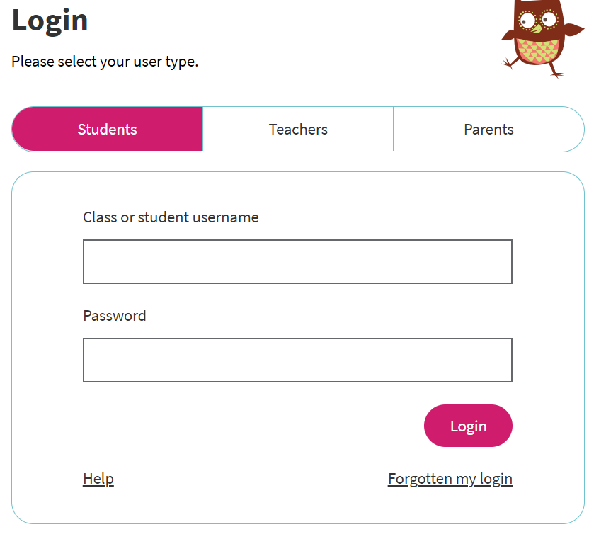
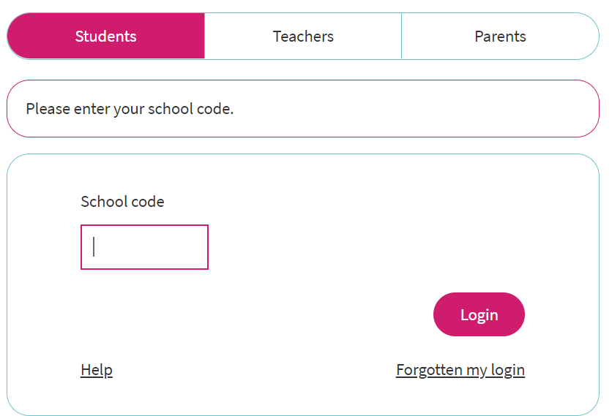
Once logged in the pupils will see this page:

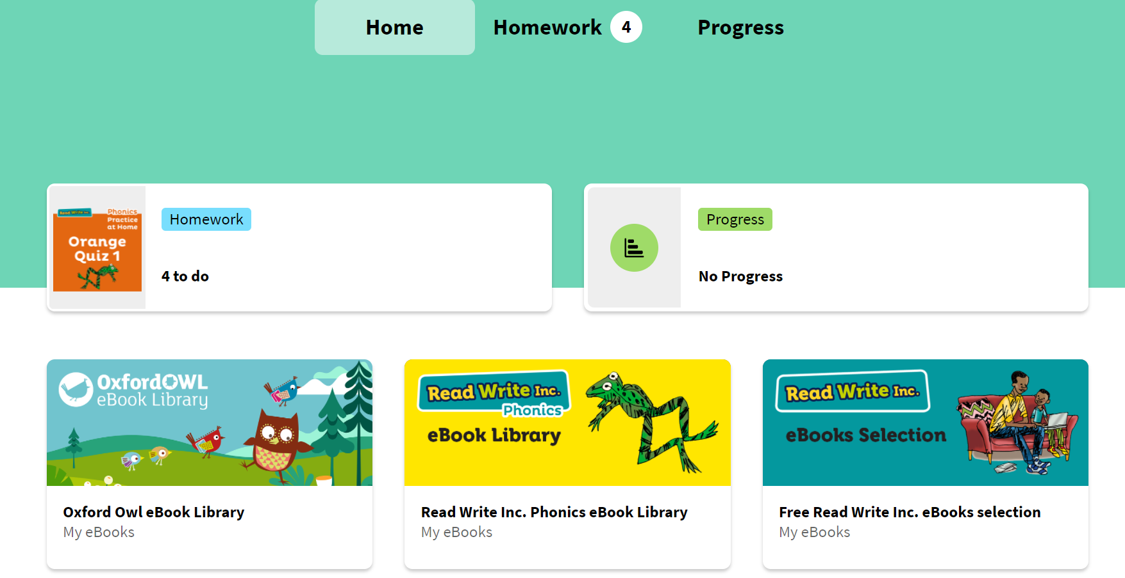

Click this and the books and quizzes assigned will be there.
They can use it in school or at home.

