Year 5 Homework: Spring 1
Choose any piece of homework to complete each week. Be as creative and imaginative as you can!
Spellings, times tables and daily reading practiced each week.
Create a crossword about forces  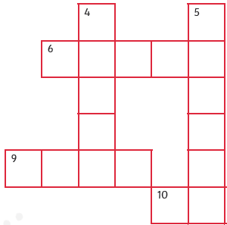  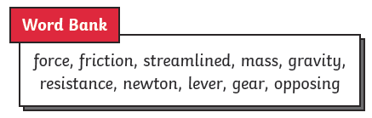 | Which toys use pulling force?  Which toys use pushing force?  Which toys use both forces?  Draw your own toys that use push or pull forces.  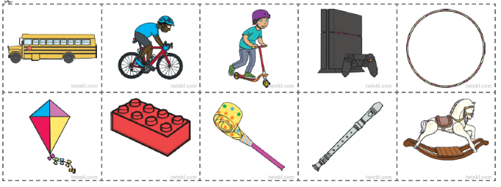
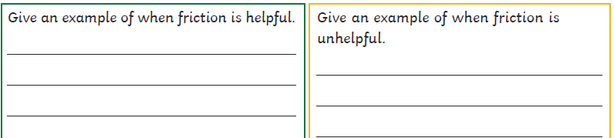

Make a paper plane and investigate the effects of air resistance on falling objects.  Time how long it takes for it to fall to the ground.  Can you create a different paper helicopter that will fall more slowly?  Consider how you can alter its design to increase air resistance.  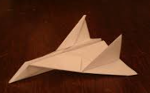 |  | Scientists use chemical reactions to create useful new materials.  Create a fact file about a scientist and a new material they made.  

