Autumn Term 2 Homework - Space and more
Complete one homework task each week in your homework book!
Space meal.  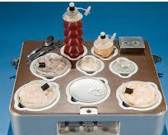  Plan a space friendly meal! (Something that won’t cause a mess if it floats off!) What would your main meal be? What would you have for pudding? What would you choose to drink? Have you planned a balanced diet? | Be creative.  Create a piece of artwork from the environment to show the changing seasons. What colours can we see during Autumn and moving into Winter? What shapes do you see across the skyline?  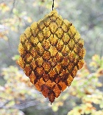 | Year 5 song/rap/poem  Write your own poem, rap or song based on Year 5 in 2023. What is different? What is the same? What do you like about school at the moment? What are you looking forward to returning to normal. Either record a performance of your rap for Seesaw or write it down. | Become a word worm!  Create a scientific language dictionary linked to space  Include the following words:  Solar system  Asteroid  Planet  Orbit  Lunar
Witches and Wizards  Imagine you have just been told by Hagrid that you are a Wizard or a Witch. Write a diary about how you feel and what you might ask.   | Make a Space postcard!  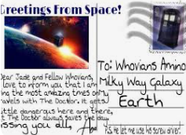  Research a planet in our solar system. Pretend you have visited this planet for a holiday and write a postcard home telling your family about it. What is the weather like? Is it hot or cold? What activities were you able to do there? | Be creative.  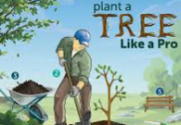  Design an information poster or model to show how planting trees and plants in urban city spaces can be helpful and good for the environment! | Be curious.  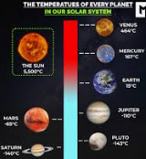  Find out the temperature for all of the planets.

