Our Schools, Our World - Biodiversity Whole School Homework
During the summer term, our school will learn how to support biodiversity to help our nature thrive. We would love your whole family to get involved at home and make a beetle bucket!
Have fun and send us pictures!
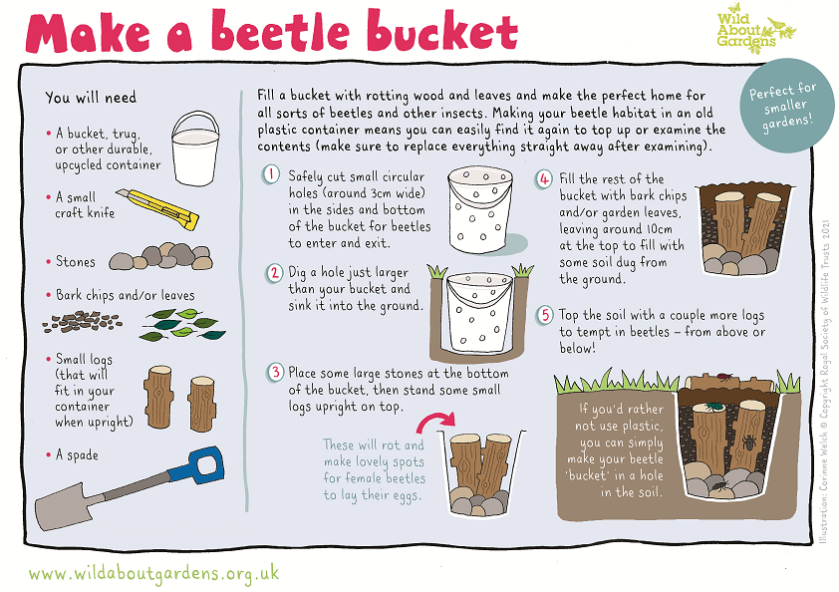
Dear Parents, we would love to hear what you think about climate change and sustainability education! Please respond to this survey to help us plan this area of curriculum.

