Year 4 Homework
Science: States of Matter and History: Romans
Choose one piece of work each week. Do the work in your Homework Book. Be as creative and imaginative as you can.
History Homework Tasks
Task 1: Write a diary as a Roman child

Task 2: Create an information leaflet about Romans

Task 3: Design or make: Roman clothing, shield, armour and a helmet for a soldier

Task 4: Write a message in Roman numerals

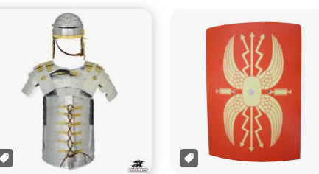

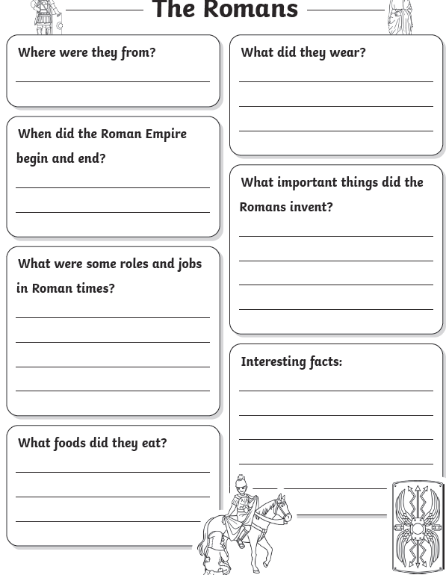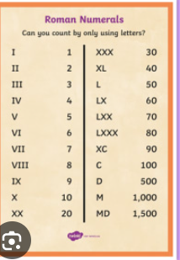
Science Homework Tasks
Task 1: Find solids, liquids, and gases.
Look around your home and make a list of different solids, liquids, and gases you can find.

Task 2: Create a water cycle experiment
Fill a bowl with water, put an empty pot in the middle, cover with film, and place in a sunny windowsill for a few days.

Task 3: Try this changing state investigation: Melt some chocolate.

Task 4: Make a poster explaining Solids, Liquids and Gas



